

Practical Report

For IoT Practical



January 1, 2022

Darshan Ramjiyani (DSP)

DOCS, KSKV Kachchh University

* **4.3 Serial Communication – Receiving Serial Data**

User enters the integral value from 0- 9 and according to the input LED will blink.

* **Arduino Code:**

int LEDPin = 13;

int baudRate = 9600;

void setup()

{

  pinMode(LEDPin, OUTPUT);

  /* Established Serial Communication. */

  Serial.begin(baudRate);

  Serial.println("Connection Establishing connection...!");

  while(!Serial){}

  Serial.println("Connection Established!");

  /* Wait until Serial Communication not established. */

  while(!Serial){}

  /* Send data through Serial Communication. */

  Serial.println("- Name of Author : DSP -");

  Serial.println("---------------------------------------------------------");

}

void loop()

{

  char ch;

  Serial.println("Waiting for integeral data from 0 to 9...");

  while(Serial.available() == 0){}

  if(Serial.available() > 0 )

  {

    ch = Serial.read();

    if(isDigit(ch))

    {

      Serial.print("LED blinks ");

      Serial.print(ch - '0');

      Serial.println(" times.");

      for(int i = 0; i < ch - '0'; i++)

      {

        digitalWrite(LEDPin, HIGH);

        delay(1000);

        digitalWrite(LEDPin, LOW);

        delay(1000);

      }

      Serial.println("Blinking Process Done");

    }

  }

}

* 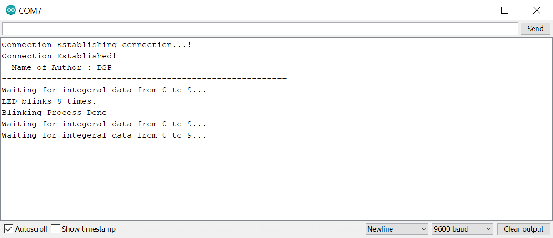Output:

Output From Dwaidh Terminal